

JSC “VENDIPLAS”;

Reg. no. 303305978; VAT Number LT100008600711;

Address: Gaiziunu str.4, LT-50126 Kaunas, Lithuania;

Phone +370 37 302123; +370 640 53528;

E-mail: [info@vendiplas.com](mailto:info@vendiplas.com); [www.vendiplas.com](http://www.vendiplas.com)

**UNDERWATER POOL PLATFORM QUOTE REQUEST FORM**

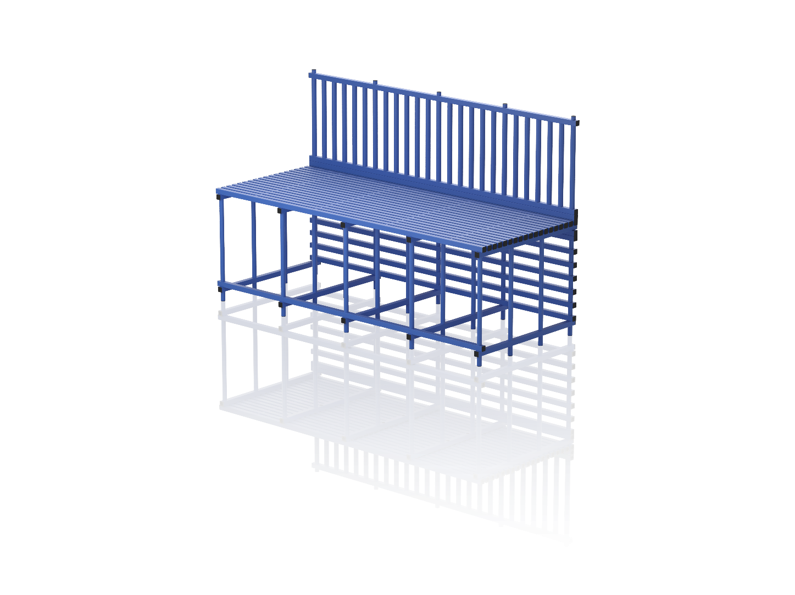

H1

Side B

Side A

Side C

Side D

Side C

Side D

Side A

W

Side B

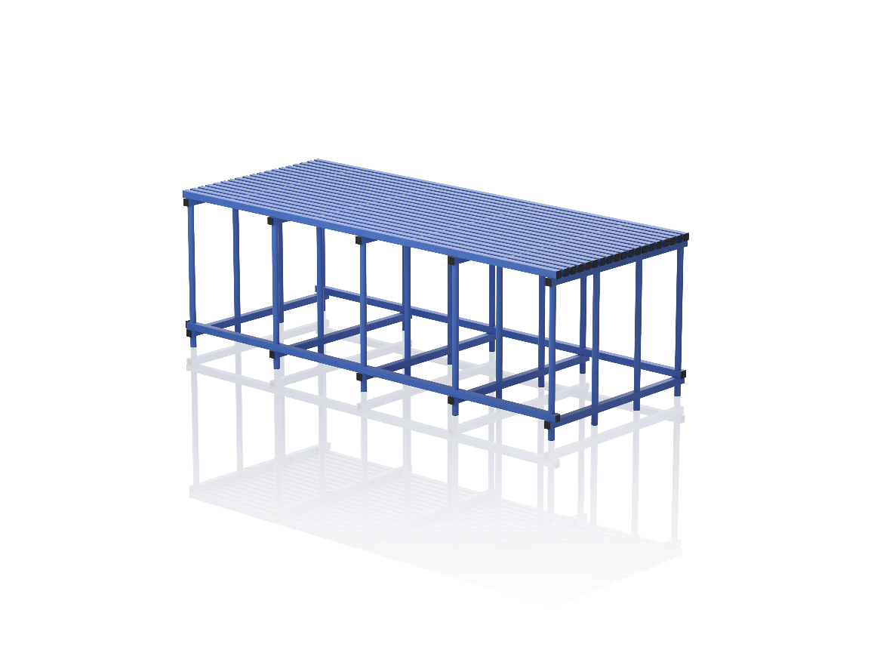

L

H

|  |  |
| --- | --- |
| PLEASE STATE | |
| Length (L): | cm |
| Width (W): | cm |
| Height (H): | cm |
| Handrails: Yes or No |  |
| Bottom protection*: Yes or No |  |
| *\*To prevent swimming under the structure* | |
| If Handrails are required please state: | |
| Height (H1): | cm |
| Which sides: A, B, C, D |  |
| If Bottom protection is required please state: | |
| Which sides: A, B, C, D |  |
| Additional information (floor slope, ladders or etc. in the platform zone): | |
| Colour option: Blue | |