**UNDERWATER POOL PLATFORM**

**QUOTE REQUEST FORM**

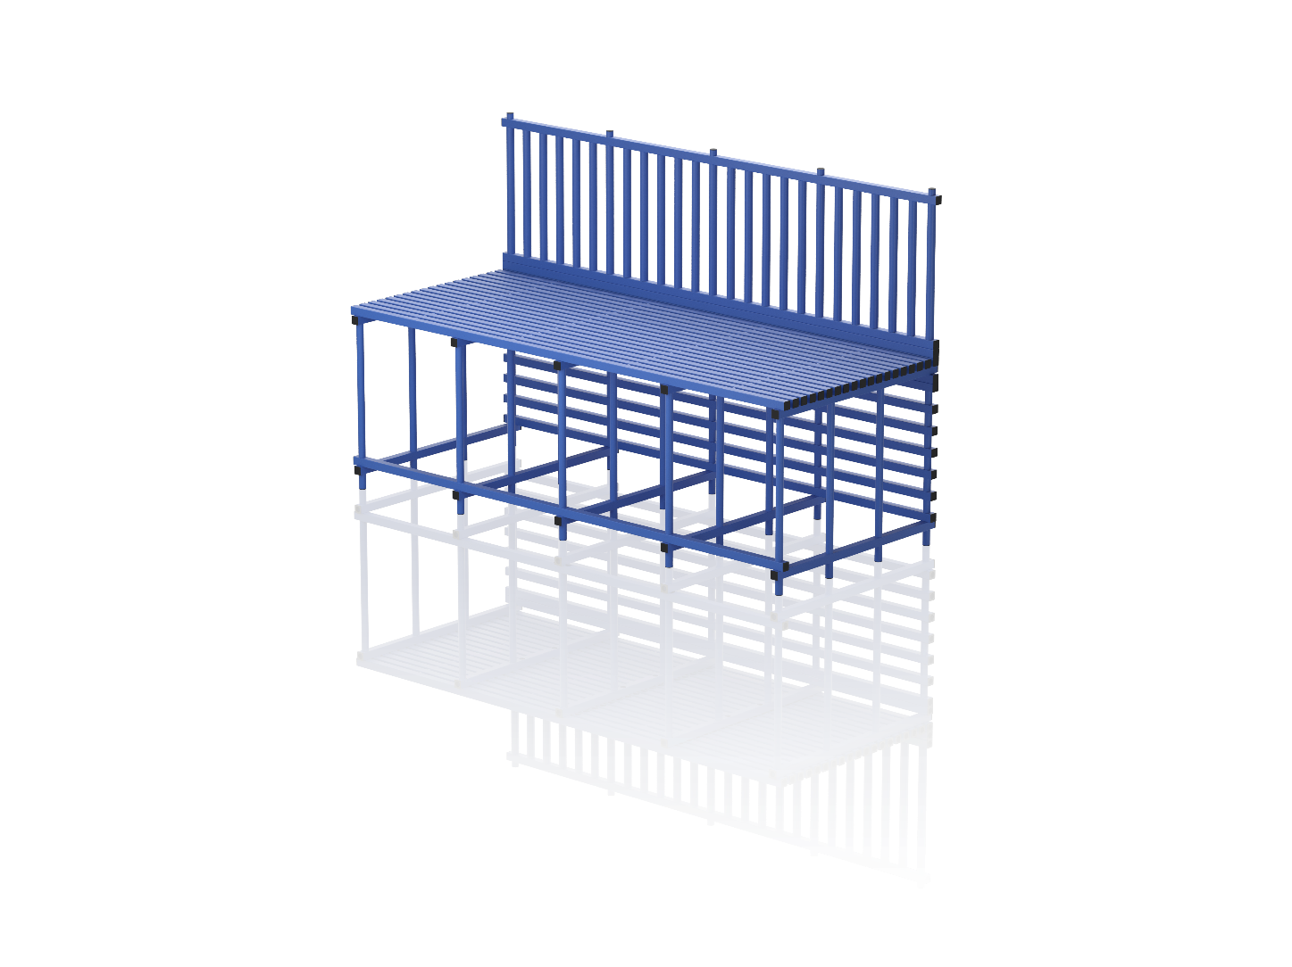

Side B

Side A

Side C

Side D

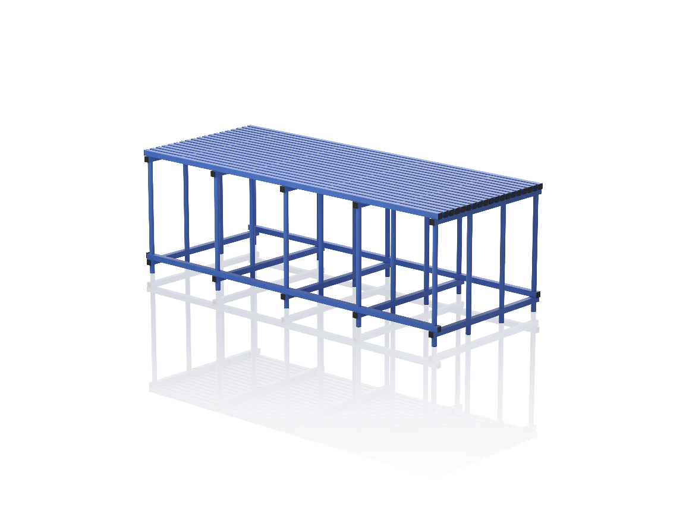

L

H

W

Side B

Side A

Side C

Side D

H1

|  |  |
| --- | --- |
| **PLEASE STATE** | |
| Length in cm (L): |  |
| Width in cm (W): |  |
| Height in cm (H): |  |
| Handrails: YES or NO |  |
| If Handrails are required please state: | |
| Which sides: A, B, C, D |  |
| Height of the handrails in cm (H1): |  |
| Bottom protection*: YES or NO |  |
| *\*To prevent swimming under the structure* | |
| If Bottom protection is required please state: | |
| Which sides: A, B, C, D |  |
| Additional information (slope, steps, ladders, or other items in the platform area): | |

Please provide us with your required specifications and measurements, along with several photos of your pool from different positions including ladders, lamps, steps, and other objects.

Send the completed form to [sales@vendiplas.com](mailto:sales@vendiplas.com) with your delivery details and contact information.

We will provide you with a quotation based on your information.

JSC “VENDIPLAS”;

Reg. no. 303305978; VAT Number LT100008600711;

Address: Gaiziunu str.4, LT-50126 Kaunas, Lithuania;

Phone +370 689 00500; +370 640 53528; +370 37 302123;

E-mail: sales@vendiplas.com, [info@vendiplas.com](mailto:info@vendiplas.com);

Website: [www.vendiplas.com](http://www.vendiplas.com); Facebook and LinkedIn: @vendiplas